**Armistice Celebrations in Epsom’s twinned French city of Chantilly**

On Saturday 10th Nocvember 2018, I, Céline Winmill, my husband, Ian Winmill, and our daughters, Jo-Anne, 14, and Noémie, 12, travelled to Chantilly to take part in their Centenary celebration of the First World War Armistice.

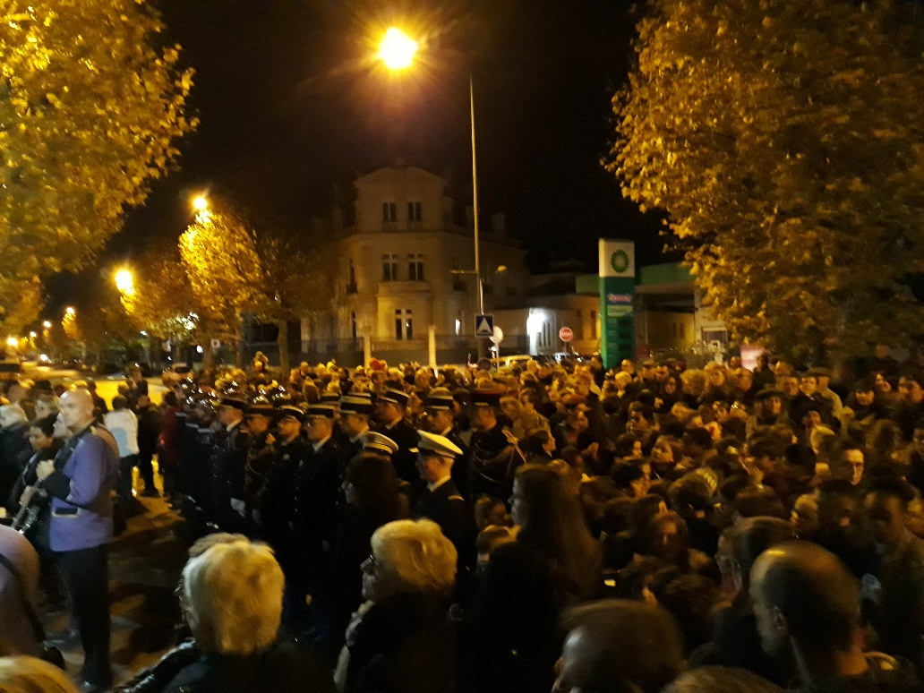

From 6pm, a march in the cemetery of Bois Bourillon was the place where French and British soldiers’ letters were read and wreaths were laid on their graves, whilst many local and international guests attended. An official gathering later took place in front of the Monument aux Morts where the local orchestra played and local primary school children sang the French National Anthem. The crowd was considerable in number in both gatherings and very respectful of the solemnity of the moment, particularly when a two-minute silence was observed.

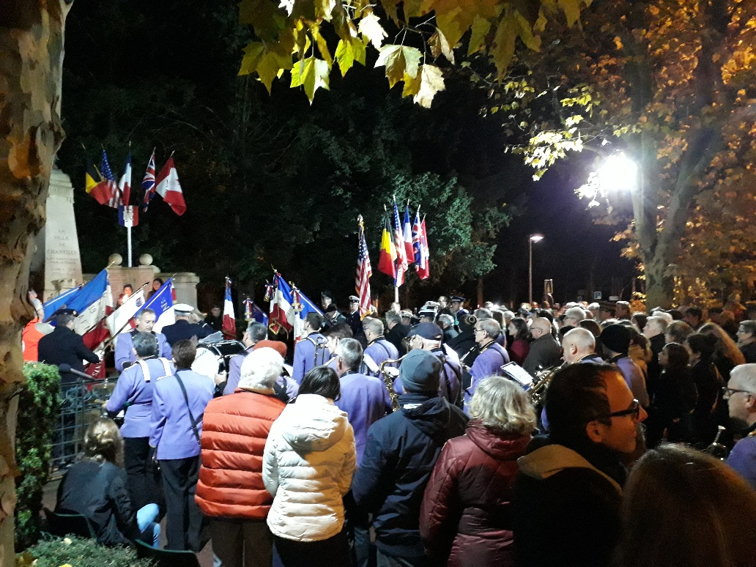

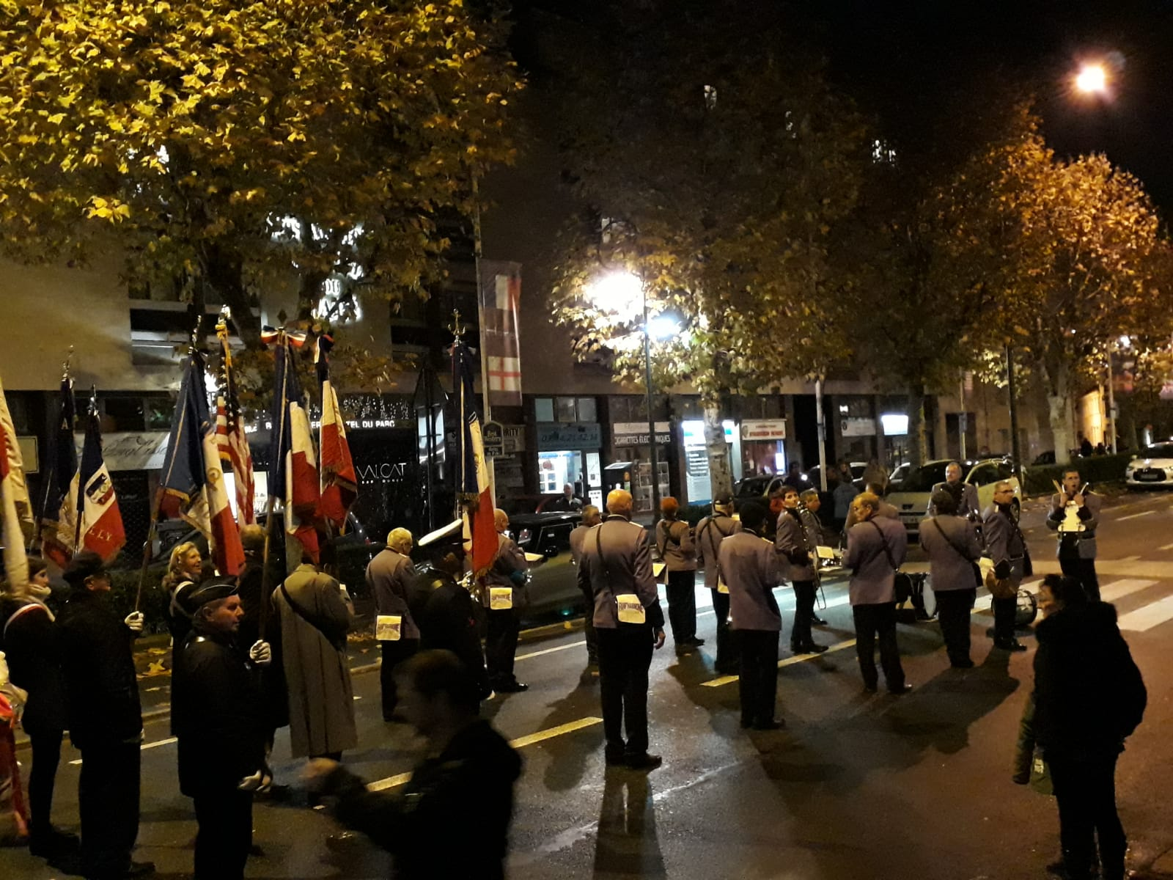

The officials then formed a parade which led all to the Mairie where canapés and refreshments were served and where we were welcomed by Madame le Maire and Mathilde Marguerit, a heavily involved history teacher of the local collège/ secondary school. We also had the pleasure to meet the President fo the French Twinning Committee and our delightful host family, Karren Perronet her husband, Lionel Abboussouan and their two sons, Calixte, 12 and Quentin, 8 – Quentin was one of the National Anthem primary school singers. All left the Mairie at approximately 8pm, all glad the heavens did not open and that the temperature was actually quite mild. After agreeing to meet up the following morning for the Church of England service, we parted from Madame le Maire and her guests to the Perronet-Aboussuan’s home. Both Lionel and Karren are excellent English-speakers and we were impressed with Calixte’s fluency in English as he conversed a lot in English with Jo-Anne and Noémie. He was more than happy to direct us, in our car, to his home giving directions in English!

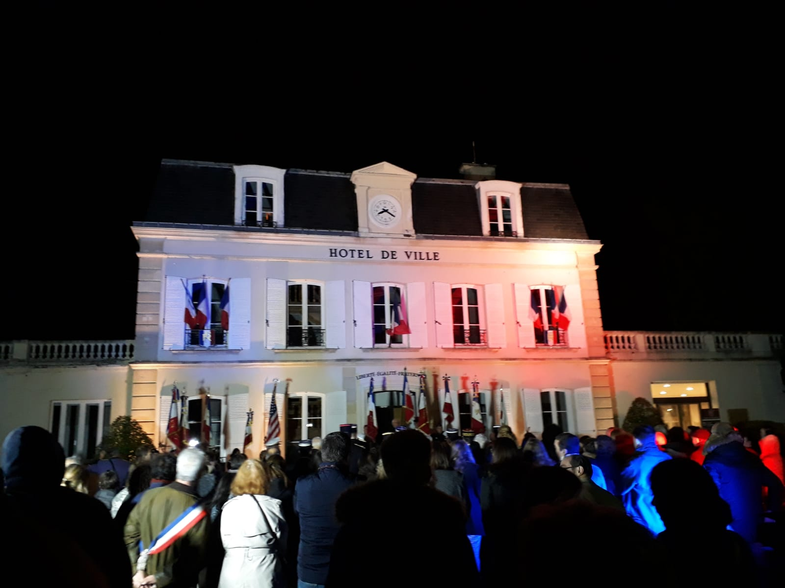

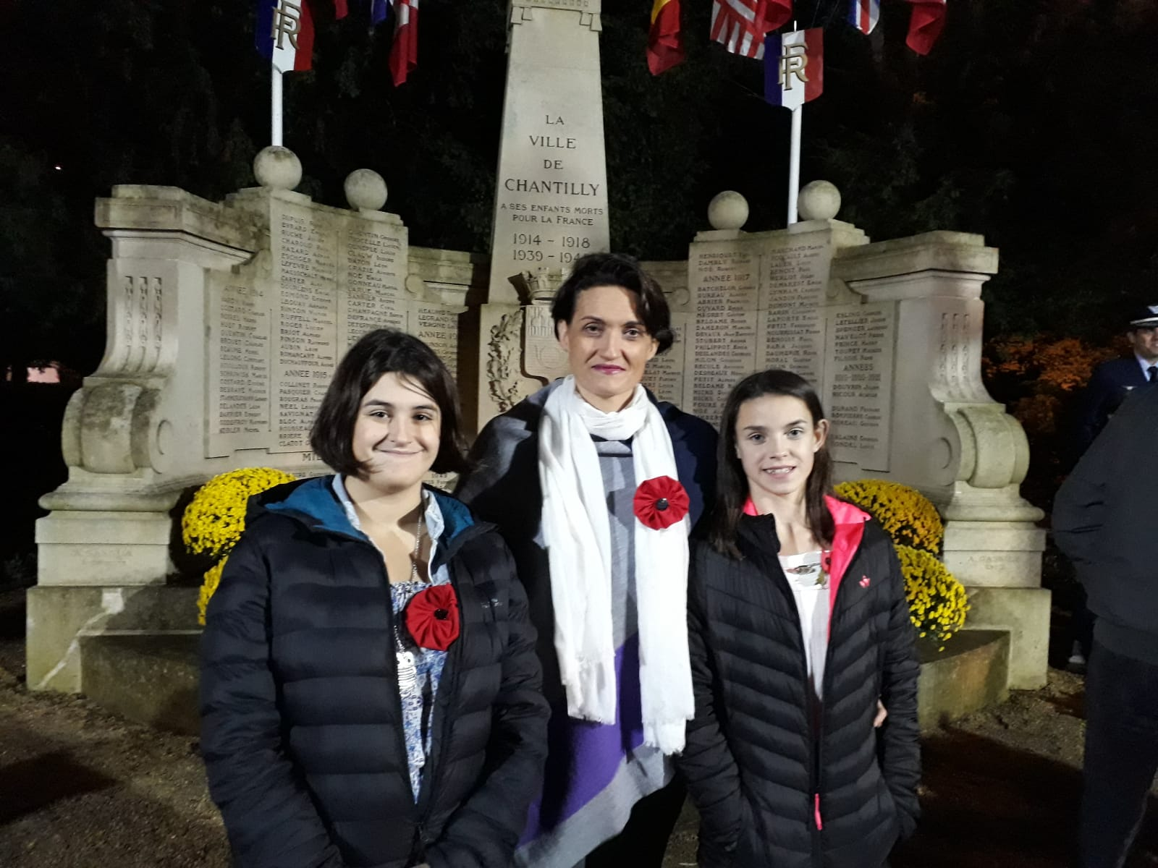

After a great evening discussing travelling, language learning, the history of Chantilly, its culture of horse racing and training, French and English cheeses, the baguette versus cheese crackers and pickles, we all went to bed knowing the Sunday would be busy for all: both the boys needing to be at the Mairie bright and early, Quentin singing, Calixte selling Bleuets ( the French equivalent of Poppies), the Winmills attending the Service with the British community of Chantilly at the Church of Saint Peter’s.

The early morning wake-up call was not too hard as a trip for the children to get their parents croissants and fresh baguettes got us all out of bed in a good mood! After enjoying our fresh croissants and tartines, dunked in our chocolats chauds or café ( obligatory French breakfast custom!) we all headed off out to our respective commitments.

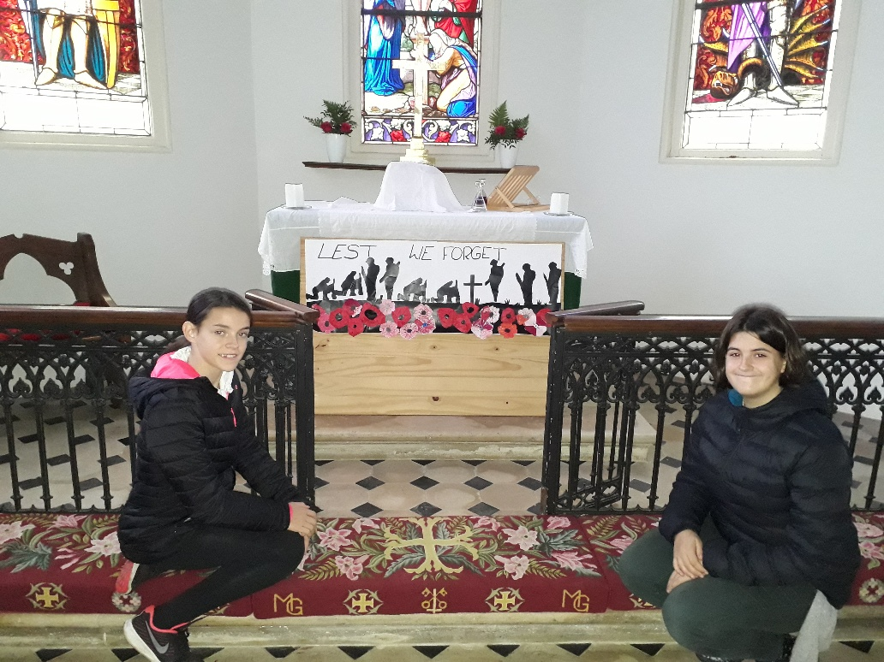

The service in St Peter’s Church , led by Revd Sarah Tillett was marvellously welcoming with a British Community who is obviously very close-knit, supportive of one another, warm, inviting and easy to talk to. Jo-Anne and Noémie were able to read the letters of Archie Paxton, an 19 year-old British soldier from Epsom who died during the first world War. In those letters, one could sense the pride, honour and dedication Archie had for his country but also the horrendous conditions he had to sustain in the trenches as well as the devastation in then fields surrounding him.

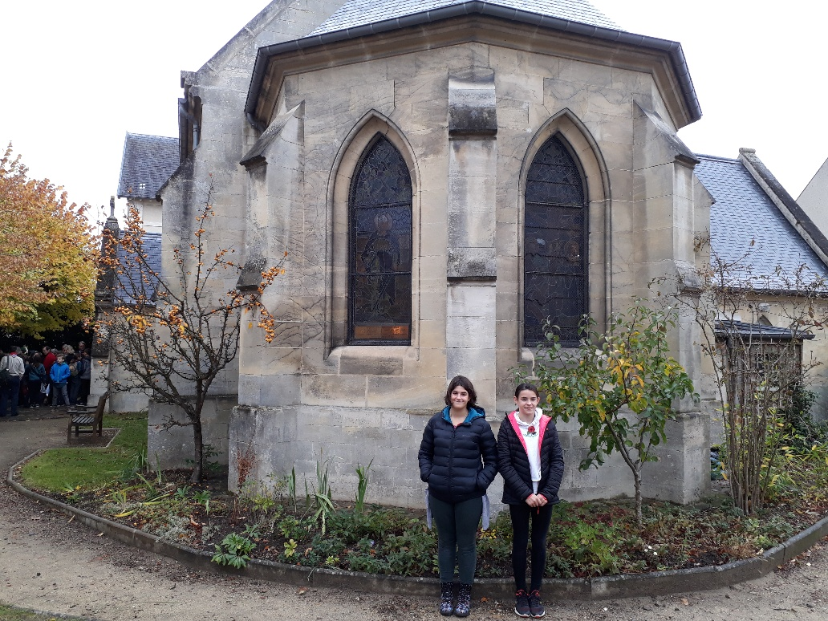

We had little time to chat to the community but managed to speak to some of them, come from Great Britain or New Zealand! Speaking about our mutual concerns over the Brexit situation could not be avoided as we walked to the Mairie for the final parade and commemorations at the Monument aux Morts where, this time, the bitter chill of November together with the pelting rain, got us all to try to imagine what it must have been like to sit in a muddy trench rather than stand there, remembering those who made the ultimate sacrifice for the freedom and hindsight we now all enjoy and wish to protect.

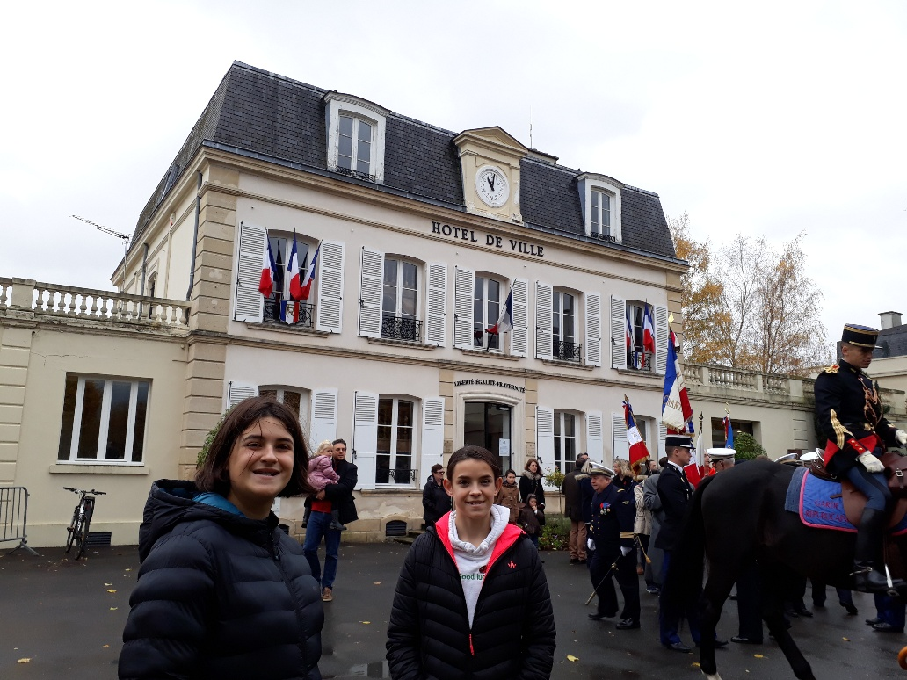

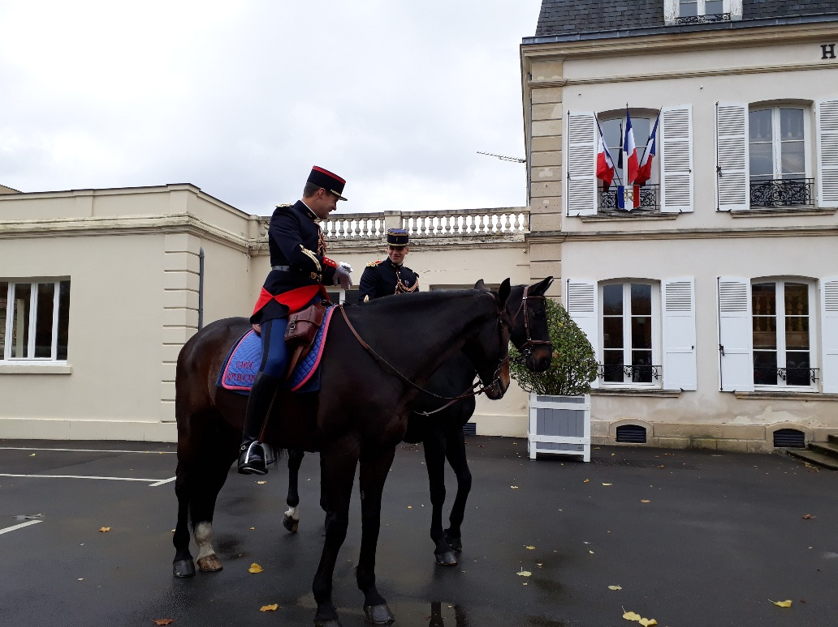

It was then that we met Marie-Claude Fontaine who is looking to organise an exchange with Bleinheim High school in Epsom and also, to come to Epsom in February to judge one of the French Rotary Speaking Competitions.

Final goodbyes and goodwishes were exchanged with Mme Marguerit, Madame le Maire, and with M. Woerth, previous Maire of Chantilly ( until 2017) and also current deputy at the French Assemblée Nationale and président of the Assemblée Nationale Finance Committee.

This trip has not only made us discover Chantilly for the first time but also, I hope, made more solid links between French teachers and committee members who will, hopefully in the near future, see our twinning initiatives become more numerous and more successful.

*Letters from Archie Paxton to his mother from the trenches.  
  
  
Thursday May 8th 1916  
Dear Mum  
I arrived here yesterday and happened to be posted to the one company that is at present in the trenches. I am at present in my dug-out, which I share with a man called Williams. He is three months junior to me, and is in command of a platoon. I am only second in command of a platoon at present, but as soon as I have had a little more experience I hope to get one.*

*This is a fairly lively part of the line, and probably will become much livelier.*

*We are infested with rats here, at night in bed you hear them scampering up and down the walls of the dug-out and all over the place, however,  as long as they don’t run over me or over my face like one officer had, I don’t mind.*

*Please will you send me that tunic that didn’t arrive in time for me to take, as if this one gets wet through I have nothing else to put on. I am going to get a pair of trench-boots as soon as I can, as the mud here is awful. Please give my love to everyone and tell them I will promise to answer any letters I get.*

*your loving son  
Archie  
  
  
19th June 1916  
Dear Mum,  
Thanks awfully for the letter. I am now in the old barn, we have got two little kittens here, one all black and one tabby, I have got a grudge against the black one as it left a deposit on my bed yesterday.*

*It was awfully good of Mr Beucke to send me those pipes, I have just written to thank him.*

*There is a little village behind our trenches absolutely in ruins, the Church has only got one wall left standing.*

*By the way if I get  killed, write to Doris and let her know, as she is a dear girl, and we were awfully good pals, of course I am not engaged to her or anything absurd like that, but we are very fond of each other and I am sure you will agree there is no earthly reason why we shouldn't be.*

*Best love to all  
ever  
your loving son  
Archie*

*Archie died aged 19.*